**Natoaganeg School Mission Statement**

**Follow us on Facebook:**

**Natoaganeg School**

**Website:**

**www.eelgroundschool.ca**

**Natoaganeg School strives**

**to have students prepared**

**with necessary skills to**

**become responsible and**

**successful lifelong learners.**

**To create a positive learning environment**

**that will inspire ALL to believe in developing to their full potential.**

**MOTTO: When you Believe,**

**You will Achieve!**

**Schedule**

Breakfast served 8:10 – 8:45am

Classes begin 8:45 am

Morning announcements 8:50 am

**Lunch:**

K4-Gr.2 11:40 – 12pm

Gr.3-5 12 – 12:20

Gr.6-7 12:20 – 12:40

**Dismissal:**

K4-Gr. 2 2:00 Pm

Gr.3-8 2:30 pm

**Attendance Policy**

School attendance is taken at 8:45am. Breakfast is served from 8:10 – 8:45 am. Student’s that are walking should arrive as close to 8:30am as possible (especially if they are eating breakfast)*.*

Voting for Kraft Hockeyville begins on April 9th 2021. Natoaganeg School supports Elsipogtog First Nation in their bid to be named Kraft Hockeyville 2021. On Thursday April 8th we will be showing our support by having a Jersey Day at school, all students and staff are encouraged to wear a jersey to show support.



**SUCCESSFUL NEWSLETTER DELIVERY BALLOT**

Sign below to indicate that your son/daughter has delivered to you this month’s newsletter. Have your child return this ballot to the ballot box located at the school office by Friday, April 23, 2021.

At the end of the month a draw will be made for a gift certificate from all the ballots that are returned.

*March Winner: Pago’si Dutcher*

_____________________________________________ ________________________________________________________

**Parents Signature**  **Childs name Class**

Mental Wellness





**Mi’k maq word of the day**

Maqtawe‘k

It’s black.

**Mekwe’k**

**It’s Red.**

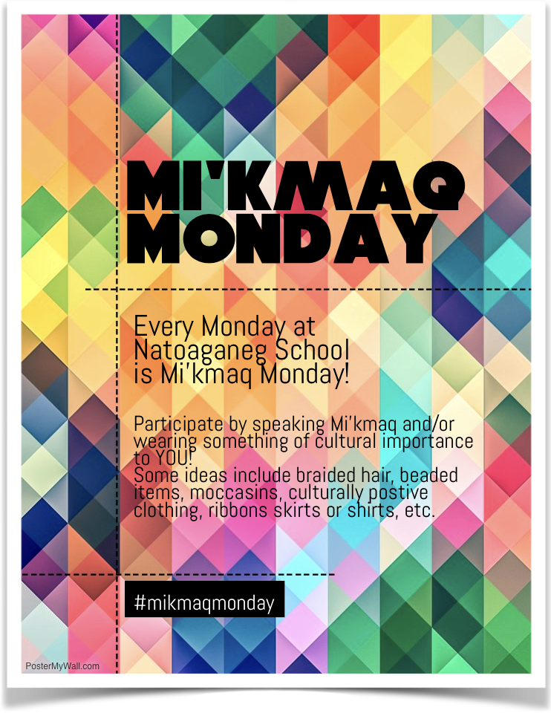

Wataptek

It’s yellow.

**Welitpamu’k**

**Very nice color.**

**Talamu’k?**

**What color is it?**

**Kelulk Mijipjewey – We Eat Good Food**

At Natoaganeg School we do our best to impart a message to the students that promotes healthy foods and healthy food choices.

One way we do this is by providing the children with a healthy and nutritious breakfast, mid-morning snack and lunch each day.

If children bring a snack or lunch from home, they should come prepared with a healthy choice that is low in sugar and sodium.

Some examples of an appropriate snack are:

applesauce, fruits, veggies, cereal bar, granola, yogurt, cheese, crackers.

Sugary snacks like chocolate, juice, chips and cakes should not be brought to school.

Visit our website for photos and recipes!

[www.eelgroundschool.ca](http://www.eelgroundschool.ca)

PATHS® IN OUR SCHOOL

Parents…have you noticed your children complimenting you and others more? Or maybe your child has brought home a compliment list from school? During PATHS® time, one child is chosen to be our PATHS® Kid of the Day. This student helps out with the lesson as a special helper. At the end of the PATHS® lesson, the class gives compliments to the PATHS® Kid of the Day. During this time, we learn how to give a compliment and how to receive a compliment. Giving compliments helps build self-esteem in our students by pointing out their accomplishments and positive things that they do. We notice that the children try harder to make good choices and are proud of their skills!

Recently, members of the Natoaganeg Sewing Club sewed hundreds of beautiful masks to ensure that our most precious little ones continue to stay safe throughout the COVID pandemic. Thank You Mary Ginnish, Josie Trevors, Madeline Ward, Mary Stella Tenass and Carol Anne Francis for helping keep students and staff safe.

Parent Teacher Day will be held on Friday, April 9th. Attached to this newsletter is a Parent Teacher Preference Form. Please fill out the form and return it to the school as soon as possible.

**Natoaganeg School**

**11 Riverview Road East**

**Eel Ground N.B.**

**E1V-4G1**

**Terri Anne Larry, Principal Phone (506) 627-4615**

**Fax (506) 627-8597**

Pentamuikus Newsletter April 2021

Macintosh HD:Users:Reception:Desktop:rainboots.jpg

With the warmer weather coming and the melting snow, the playground is becoming muddy and wet. Please ensure your child has appropriate footwear for outside as well as indoor shoes.



