|  |
| --- |
|  |
| **Apuknajit** Newsletter **February 2024** |
|  |

Natoaganeg School

11 Riverview Road East

Eel Ground NB,

E1V 4G1

Terri Anne Larry, Principal Phone 627-4615

Jenny Sonier, Vice Principal Fax 627-8597

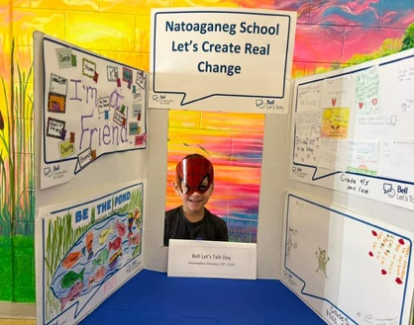

Students and Staff at Natoaganeg School engaged in discussions, poster making, photo ops, and lots of positive affirmations as part of Bell Let’s talk Day. Thank You Chief Ginnish and council, Miramichi Mental Health and Suicide Awareness, Rising Sun Treatment Centre, Mawlugutineg Wellness, Mi’kmaq Child and Family, Eel Ground Health Centre and our many community partners as we continue to work towards positive change. **#BellLetsTalk**

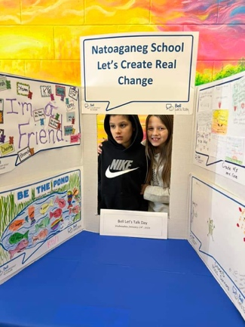

**Pink T-Shirt Day**

**Wednesday February 28th**

On **Pink T-Shirt Day,** everyone is encouraged to wear something pink to symbolize that bullying anywhere will not be tolerated. For students that do not have a pink t-shirt of their own, the school has extra’s they can borrow.

**February 7 Yellow Shirt Day- Suicide Prevention Awareness**

**February 9 PD Day-No school for students**

**February 14 Valentine’s Day**

## February 16 Random Act of Kindness Day

## February 19 Family Day Holiday

**February 23 Math Day**

## February 28 Pink T-shirt Day

**March 1 PBIS Rewards Day – Early Dismissal**



**Please ensure that the school has the most up to date phone numbers for your children. If you have changed your phone number or the emergency contacts for a student have changed, please notify the office at 627-4615.**

**Basketball**

**Elementary**

Feb.1 Jamboree @ Dr. Losier

Feb.15 Game @ Miramichi Rural 3:30pm

Feb.22 Jamboree @ Dr. Losier

**Middle School**

Feb.7th @ Esgenoopetitj 4:30pm

**Skating Schedule**

**K4-Gr.4**

9-9:45am

Feb.6, Feb.20, Mar.12

**Grade 5 – 8**

10:50 - 11:40am

Feb. 23

*These are **on-ice** times

 **PATHS® IN OUR SCHOOL**

Parents…do you know that your child is learning and talking about feelings in our classrooms? The teachers are working with the students to help them understand their feelings better during our PATHS® lessons. They also are learning to recognize how others are feeling too. Learning to understand their own and other’s feelings helps our students to get along better with each other. It helps the children to talk to each other better when they have problems. It helps them build their friendship skills. Ask your child about the different feelings they are learning about in class!

**Kelulk Mijipjewey – We Eat Good Food**

At Natoaganeg School we do our best to impart a message to the students that promotes healthy foods and healthy food choices.

One way we do this is by providing the children with a healthy and nutritious breakfast, mid-morning snack and lunch each day.

If children bring a snack or lunch from home, they should come prepared with a healthy choice that is low in sugar and sodium.

Some examples of an appropriate snack are:

applesauce, fruits, veggies, granola, yogurt, cheese, crackers.

Sugary snacks like chocolate, chips and cakes **should not** be brought to school.

**Homemade Chicken Noodle Soup**

* 6 Cups Chicken broth
* 3 cups cooked shredded chicken
* 1 cup shredded carrots
* 2 cups egg noodles
* ½ c diced celery
* Salt & pepper to taste
* Pour chicken broth in a large sauce pan.
* Add chicken, carrots and celery. Bring to a boil, reduce heat & cover, let simmer for 5 minutes.
* Add egg noodles, simmer another 5 minutes until noodles are tender.

**keskuk**

**(guess-goo-k)**

**It’s heavy.**

**Mu meko’tinuk**

**(moo meg-oh din-ook**

**It didn’t cost much.**

**Ta’sioq?**

**(Dah-see ohk)**

**How many are with you?**

**Mi’kmaq Word of the Day**



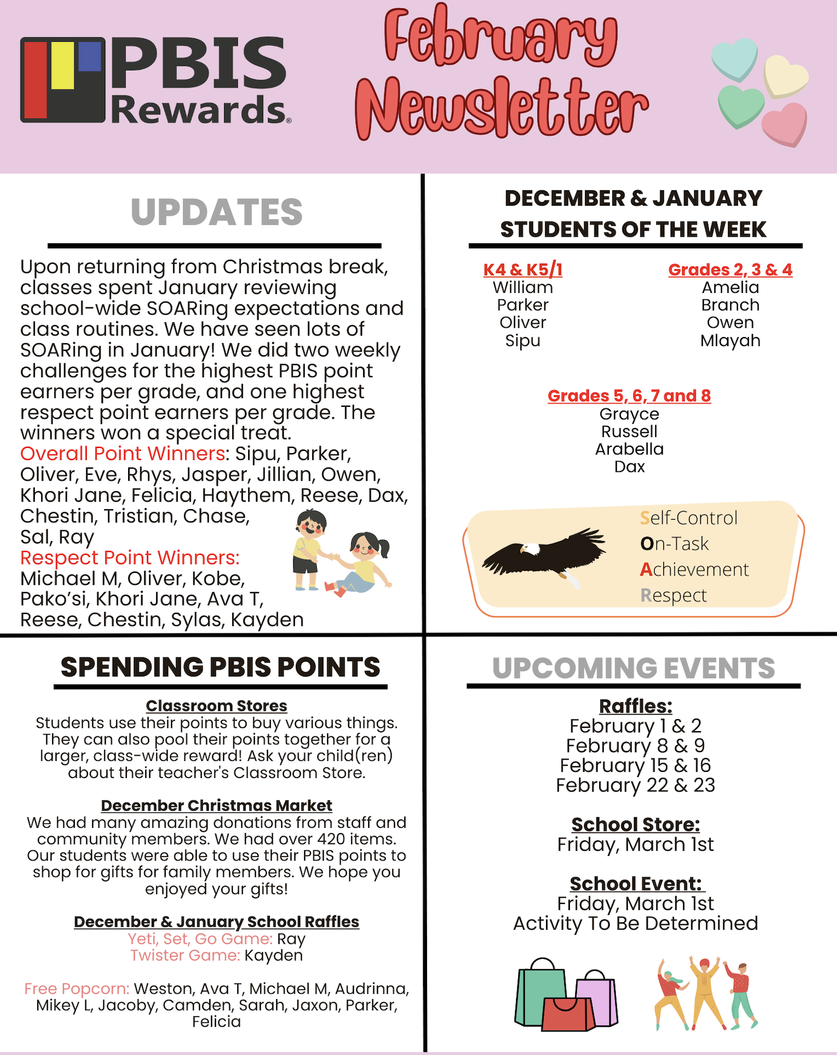

**SUCCESSFUL NEWSLETTER DELIVERY BALLOT**

Sign below to indicate that your student has delivered to you this month’s newsletter. Have them return this ballot to the ballot box located at the school office by Friday, February 23, 2024.

At the end of the month a draw will be made for a gift card from all the ballots that are returned.

*January Winner: Dax M.*

___________________________________________________________________________________________ **Parents Signature**   **Grade** **Childs name**

**Natoaganeg School Mission Statement**

Natoaganeg School strives

to have students prepared

with necessary skills to

become responsible and

successful lifelong learners.

To create a positive learning environment

that will inspire ALL to believe in developing to their full potential.

MOTTO: When you Believe,

You will Achieve!