Oct.29
Half Day for students
Oct. 11
Thanksgiving Day
School Closed

Oct.1st
Treaty Day
School Closed

Natoaganeg School  11 Riverview Road East  Eel Ground N.B.  E1V-4G1  Terri Anne Larry, Principal Phone (506)627-4615  Fax (506) 627-8597  Dear Parents/Guardians:  Our first month of school is complete. It has been a successful month of getting back into the school routine for both students and staff.  Thank You Families and Caregivers for your patience as we navigate these new guidelines and routines. | Wikewiku’s  October 2021  Newsletter
The weather is changing and the days are getting colder. Please ensure your child is dressed appropriately as we go outside for lunch recess every day and gym class occasionally.  Students also need a pair of indoor shoes to change into when they arrive at school. | Natoaganeg School will be following the Band Administration COVID 19 Policy.  Therefore, please be advised that upon entering Natoaganeg School ALL visitors aged 12 and up must provide Proof of Vaccination along with photo identification.  If you cannot provide the required documentation, you will not be permitted inside the school.

ImpOrtant Dates
Nov.2
Picture Day
Sept.30th National Day of Truth and Reconciliation.
School Closed.

APEGNB have reached out to our community to help design their logo for the upcoming Puttfest competition taking place in our district this spring. Puttfest will be a contest where students must design a practice putting green which sends the ball back to the player, without using batteries or electricity, rather clean energy only. The goal of this project is to increase climate change literacy in our province.
The theme of Puttfest is “Fishing Guide.” This means that the practice putting greens will all incorporate fishing, fishing materials, canoeing, etc. in their designs. For example, someone may have an oar as a part of their putting green.
Some ideas that could be included in your logo design are:
- The words “PUTTFEST 2022”
- The Mi’kmaq word for “Fishing Guide” which is “a’lutasit”
- A golf ball, putter, flag, etc.
- A putting green or other golf visuals (think golf emojis)
- Anything involving clean energy
There will be prizes awarded to the top three contestants. The awards will range from $25 - $75. This contest is open to ALL COMMUNITY students, not just students of Natoaganeg School. This includes any Natoaganeg community children who attend MVHS, Max Aitken Academy, Carrefour Beausoleil, NSEE or NSER, etc.
Students or parents can submit their design before October 23rd to either the email provided on the poster (kgallantcanada@gmail.com), or deliver them to Natoaganeg School and we will ensure they are delivered for you.

Mi’kmaq Monday

An initiative we have been doing in our school is Mi’kmaq Monday.
Every Monday we will have a smudge in the drum of the school to start the week and encourage students and staff to wear something of cultural importance to them such as braided hair, beaded items, culturally positive clothing, moccasins, etc..
We want our students to be proud of their cultural identity and we are looking forward to implementing any other cultural initiatives or ideas they have!

Mi’kmaq word of the day
Weli
(well-eh)
I am Fine
Me’taleyin
(may-de-lane)
How are you?
Weli-eksitpuk
(well-lee-ekk-sit-boog)
Good Morning
Treaty Day, October 1st marks the beginning of Mi’kmaq History Month.
https://mikmaqhistorymonth.ca/

SUCCESSFUL NEWSLETTER DELIVERY BALLOT
Sign below to indicate that your son/daughter has delivered to you and you have read this month’s newsletter.
Have your child return this ballot to the ballot box located at the school office by Friday, October 22.
At the end of the month a draw will be made for a gift card from all the ballots that are returned.
Winner for September: Jacob – K5

__________________________________________________________________________________________________________
Parents Signature Child’s Name Grade

NEKAW NAQSI P+SIN
We’re always at school
Perfect Attendance Program
The goal is to promote attendance at school, encourage punctuality, and discourage tardiness. Everyday that a class has perfect attendance they will receive a letter from the phrase NEKAW NAQSI P+SIN
The first class to spell out this phrase will receive a special reward at the end of the week in which they won.
--------------------------------------------------------------------------------------------------------------------------------------------------------------------------------------------------------------------------------------

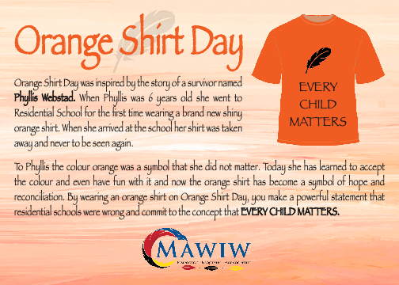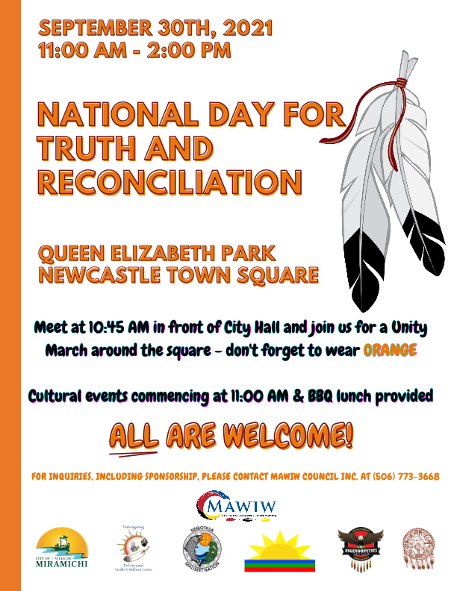

Student Leadership

Youth leaders have an invaluable and important role at Natoaganeg school. The students from grade 4-8 are given the opportunity to build upon their leadership, decision making and communication skills through their involvement in the program.
Photo: youth leaders Tristian, Sophia and Arabella help with preparations for Truth and Reconciliation Day.
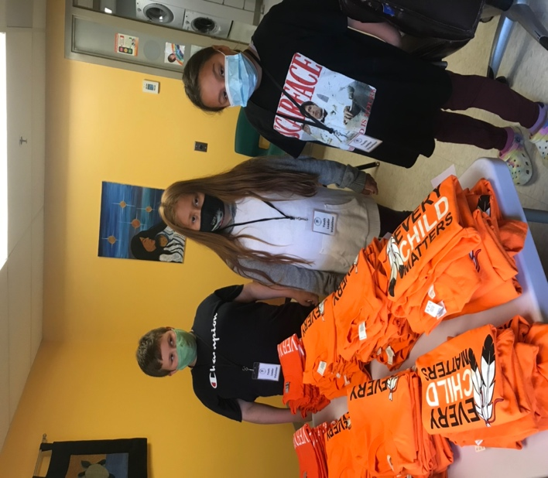
NATOAGANEG SCHOOL MISSION STATEMENT

Natoaganeg School strives
to have students prepared
with necessary skills to
become responsible and
successful lifelong learners.
To create a positive learning environment
that will inspire ALL to believe in developing to their full potential.
MOTTO: When you Believe, You will Achieve!

