Dear Parents/Caregivers:
Natoaganeg School
11 Riverview Road East
Eel Ground N.B.
E1V-4G1

Terri Anne Larry, Principal Phone (506) 627-4615
Jenny Sonier, Vice Principal Fax (506) 627-8597

  - Wikewiku’s Newsletter October
Our first month of school is complete. It has been a successful month of getting back into the school routine for both students and staff.
Important Dates
October 10th Thanksgiving Holiday No school for students
October 28th 1/2 day for students
AM – PBIS Rewards Day(Halloween Dress up/Dance)
PM – Haunted House
November 2 Picture Day

Attached to this newsletter is the breakfast and lunch menu for
October. If you are sending a snack or lunch with your child
please keep in mind our school has a healthy food policy,
ensure the snack or lunch is low in sugar.
Reminder:

If you are dropping off a student or picking a student up, please be mindful of the school bus loading zone. For student safety we ask that you use the designated parking area for student drop off/pickup.
Please do not park in the bus loading zone.

.

Weli
(well-eh)
I am Fine
Mi’kmaq Monday  An initiative we have been doing in our school is Mi’kmaq Monday.  Every Monday we will have a smudge in the drum of the school to start the week and encourage students and staff to wear something of cultural importance to them such as braided hair, beaded items, culturally positive clothing, moccasins, etc..  We want our students to be proud of their cultural identity and we are looking forward to implementing any other cultural initiatives or ideas they have!  Treaty Day, October 1st marks the beginning of Mi’kmaq History Month.  https://mikmaqhistorymonth.ca/ |  | Mi’kmaq word of the day  Weli-eksitpuk  (well-lee-ekk-sit-boog)  Good Morning  Me’taleyin  (may-de-lane)  How are you?
Parents…
Talking about what we think and feel is important. But, just as important is the skill of listening. Listening is a skill that our children are encouraged to get better at in school. At home, listening is also a skill that you want to encourage. When someone listens to us, we know they care about us. In PATHS® time, we learn that listening to each other is just as important as being able to talk about ideas, feeling and share information. If no one listens, we cannot solve problems. If no one listens, we cannot share ideas. If no one listens to us we do not feel valued. Our students are important to us all. Let’s listen to them and encourage them to listen to us too.

PATHS® in our school….

NEKAW NAQSI P+SIN
We’re always at school
Perfect Attendance Program
The goal is to promote attendance at school, encourage punctuality, and discourage tardiness. Every day that a class has perfect attendance they will receive a letter from the phrase
NEKAW NAQSI P+SIN
The first class to spell out this phrase will receive a special reward at the end of the week in which they won.

Kelulk Mijipjewey – We Eat Good Food
At Natoaganeg School we do our best to impart a message to the students that promotes healthy foods and healthy food choices.
One way we do this is by providing the children with a healthy and nutritious breakfast, mid-morning snack and lunch each day.
If children bring a snack or lunch from home, they should come prepared with a healthy choice that is low in sugar and sodium.
Some examples of an appropriate snack are:
applesauce, fruits, veggies, cereal bar, granola, yogurt, cheese, crackers.
Sugary snacks like chocolate, chips and cakes should not be brought to school.

Student Leadership
Student Leadership

Thank you, Dana, Moises, Arabella, Grayce, Jax, Dax, Dailen, Chestin and Noah for volunteering as part of our Youth Leadership Program. Over the past month you have helped to organize our World Suicide Awareness and Orange Shirt Day events; kept our cafeteria clean and tidy for all to enjoy and served up delicious and healthy salads to our students. Your leadership and commitment are very appreciated!
Missing from Photo: Felicia and Owen

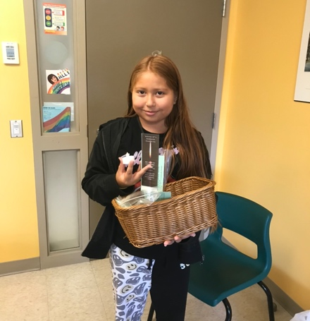
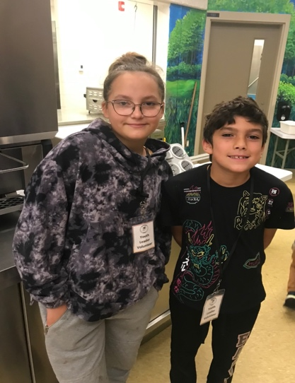
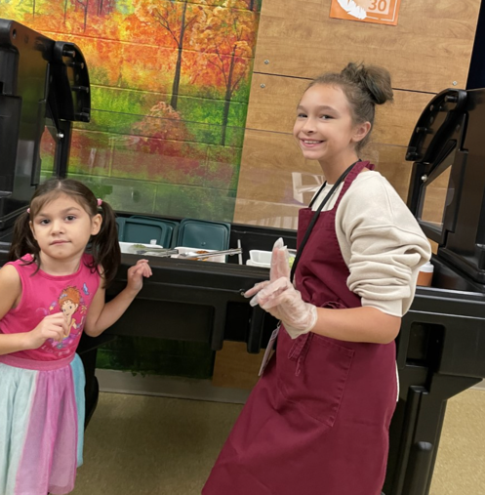

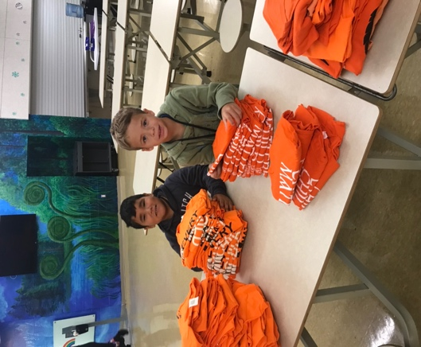
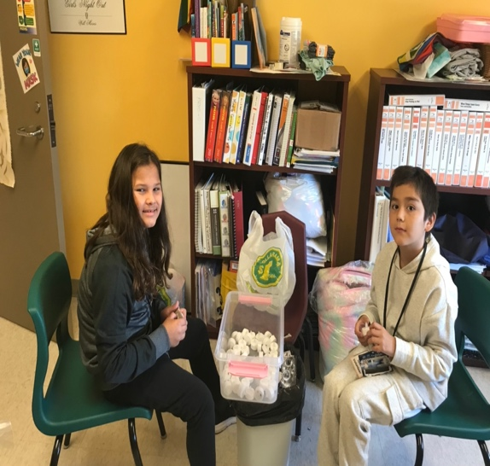
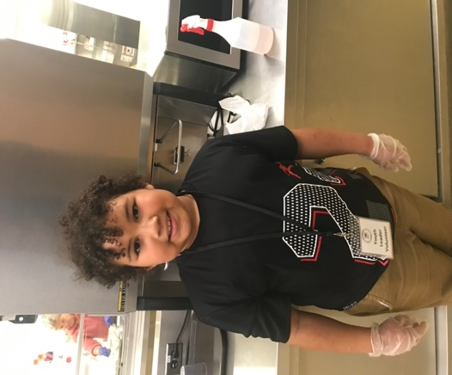
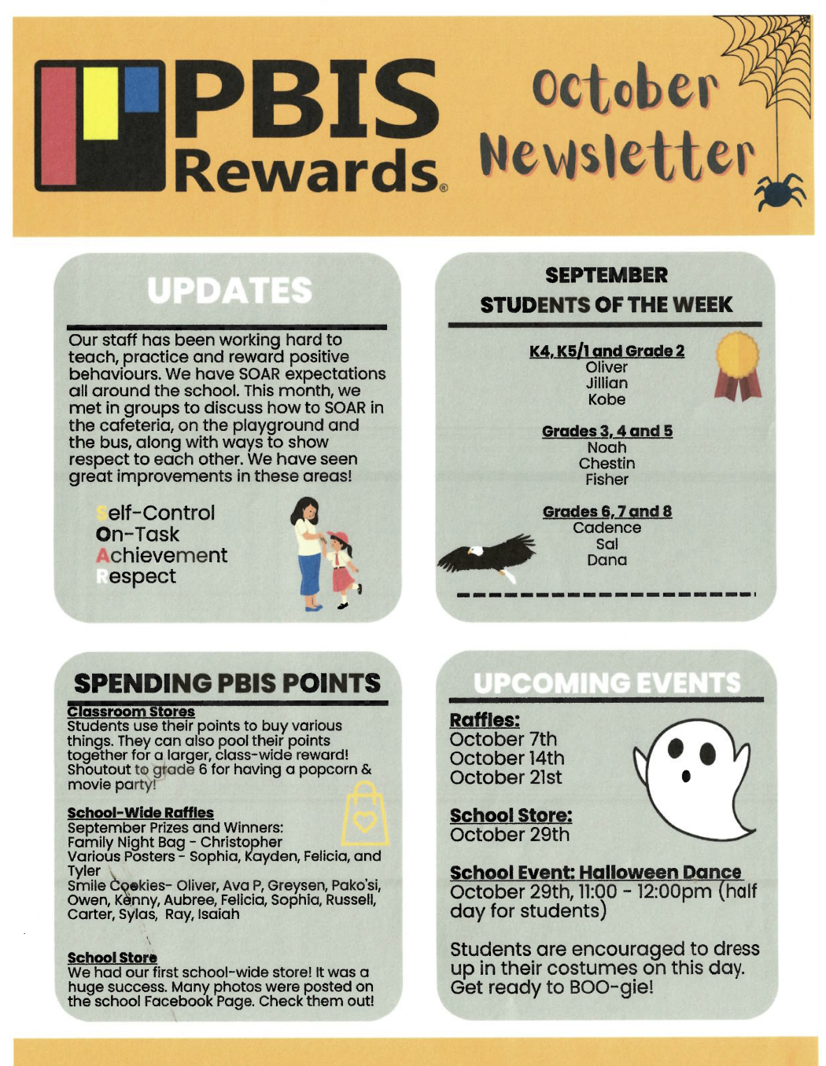

SUCCESSFUL NEWSLETTER DELIVERY BALLOT
Sign below to indicate that your son/daughter has delivered to you and you have read this month’s newsletter.
Have your child return this ballot to the ballot box located at the school office by Friday, October 21, 2022
At the end of the month a draw will be made for a gift card from all the ballots that are returned.
Winner for September: Dax M

__________________________________________________________________________________________________
Parents Signature Child’s Name Grade

NATOAGANEG SCHOOL MISSION STATEMENT

Natoaganeg School strives
to have students prepared
with necessary skills to
become responsible and
successful lifelong learners.
To create a positive learning environment
that will inspire ALL to believe in developing to their full potential.
MOTTO: When you Believe, You will Achieve!

