Natoaganeg School
11 Riverview Road East
Eel Ground N.B.
E1V-4G1

Terri Anne Larry, Principal Phone (506) 627-4615
Fax (506)627-8597

SEPTEMBER 2021  WIKUMKEWI’KUS | Dear Parents / Guardians:  In recognition of National Day for Truth and Reconciliation and Treaty Day Natoaganeg School will be closed on September 30th and October 1st  September 30th has been declared National Day of Reconciliation or Orange Shirt Day in recognition of the harm the residential school system caused children's sense of self-esteem and well-being, and as an affirmation of our commitment to ensure that everyone around us matters. In response to the Truth and Reconciliation Commission’s 94 Calls to Action, September 30th has been designated as National Day of Reconciliation and is a holiday for staff and students at Natoaganeg School. This Day of Reconciliation is an opportunity to reflect, commemorate and acknowledge the impact and history ofvresidential schools.  On Wednesday, September 29th Students and staff from Natoaganeg school will be holding a gathering to remember the children who did not come home from Indian Residential schools, to support the families who have suffered the loss of their children and to honor those who survived. Beginning at 10:30am we will wear our orange shirts as we gather for smudge, prayer and a walk throughout the community. Our gathering will conclude at the veteran’s memorial where we will join the community for a commemoration ceremony.  Excerpt from Phyllis (Jack) Webstad’s story:  When I got to the Mission, they stripped me, and took away my clothes, including the orange shirt! I never wore it again. I didn’t understand why they wouldn’t give it back to me, it was mine! The color orange has always reminded me of that and how my feelings didn’t matter, how no one cared and how I felt like I was worth nothing. All of us little children were crying and no one cared.  Watch and listen to Phyllis Webstad’s story: https://www.orangeshirtday.org/phyllis-story.html  #EveryChildMatters  To register for Truth and Reconciliation Week online event please register at this web address  https://nctr.ca/education/trw/

Light a candle near
a window at 8pm
to show your
support for suicide
prevention

to remember a lost
loved one and for
those impacted by
suicide

September 10
^{th}

Naqa’tmk

mu Ne’po’lsultinew

Se
ptember 10
^{th}

is
World Suicide
Prevention Day

Waso
qa’
tu
wasoq
nmaqan

kikju
tuopitiktuk

ukumuljin te’s ajiet

wela’kw

Wkjit apoqnmatmenen

naqa’tmk mu

ne
’po’sultinew

Mikwite’ten e’nikaq

ksite’tqanmaq aqq ta’nik

eskwi
a
’tijik

September is Suicide Awareness and Prevention Month
As we work together as a caring and loving community, we are reminded that we can all have a role in helping/guiding/supporting someone who is struggling with thoughts of suicide or are dealing with loss from suicide. Small actions can have a huge impact. When someone is struggling...
Check in with them regularly to see how they are doing
Listen supportively to what they have to say
Remember that you don’t have to have all the answers
Know and introduce them to resources in their area, if they need additional support
Be prepared to assist them in finding information, but don’t take over
This week, every student and staff at Natoaganeg School received a laminated bookmark and a flameless votive.
The bookmark has a message of light and hope in Mi’kmaq and English. The message and the light from the candle is a reminder of the hope and strength that we bring to each other and the courage to reach out without judgement or shame.
Our Teaching Staff

K4
Alisha Sweezey
EA Jackie White
K5/ Grade1
Tianna McFarlane
EA Sylvia Miller, EA Taylor Simon, EA Kyla Martin, EA Hillary Denbow
Grade1/ 2
Kara Cooper,
EA Hayley Sark, EA Micaela Hachey
Grade 3/4
Haley Doak
EA Melanie Duplessis, EA Lacey Creamer
Grade 4/5
Robbie Ross
EA Sarah Cooper, EA Nicole Matchett

Grade 6/7
Amanda Johnston
EA Ev Gray, EA Felicia Dedam
Grade 8
Joseph Canistro,
EA Tasha Hachey, EA June Augustine
Mi’kmaq Culture and Language
Natalie Larry
Language and Culture Mentor
Mary Ginnish
Math Lead
Hillary Manuel
Literacy Lead
Kayla Mutch
Phys. Ed and Health
Layne Wallace

Earlier this week registration forms were sent home. Please ensure both sides are filled out and returned to the school as soon as possible. It is very important that the school has the most up to date information for students. Phone numbers and address changes must be reported to school administration as it is imperative that staff have reliable information so they can communicate with parents/guardians.
Kelulk Mijipjewey - We eat good food
At Natoaganeg School we do our best to impart a message to the students that promotes healthy foods and healthy food choices.
One way we do this is by providing the children with a healthy and nutritious breakfast, mid-morning snack and lunch each day.
If children bring a snack or lunch from home, they should come with a healthy choice that is low in sugar and sodium.
Some examples of an appropriate snack are:
applesauce, fruits, veggies, cereal bar, granola, yogurt, cheese, crackers.
Sugary snacks, chocolate, and chips should not be brought to school.
Mi’kmaq Monday
An initiative we have been doing in our school is Mi’kmaq Monday.
Every Monday we will have a smudge in the drum of the school to start the week and encourage students and staff to wear something of cultural importance to them such as braided hair, beaded items, culturally positive clothing, moccasins, etc..
We want our students to reclaim their cultural identity and we are looking forward to implementing any other cultural initiatives or ideas they have!
EVERY CHILD MATTERS Orange T-shirt Day September 29th. Students will wear their orange t-shirts and we will meet in the cafeteria at 10:30am and go for a walk. The walk is coordinated with the Health Centre.

School Schedule
8:10- 8:30am Breakfast is served
There is always a hot breakfast option along with fresh fruit, a toasted item such as bagel, toast or english muffin and cereal.
8:35am Morning announcements
8:45am Classes begin
10:15-10:30am Nutrition Break
Students are provided with a healthy snack option, if they choose to bring a snack from home, please ensure it is low in sugar and sodium.
11:40am-12pm K4 – Gr 3/4 Lunch
12-12:20pm Gr.4/5 – Gr.8 Lunch
2 pm K4 – Gr.2 Dismissal
2:30pm Gr.3/4 – Gr.8 Dismissal
After School Activities
Soccer - Grades 4 & 5
Games will be on Tuesdays & Thursdays at 4:00 PM. We will have one practice on September 20th from 2:30-3:30. Going forward there will be short practices before games. Students should come prepared for practice & games.
Natoaganeg Soccer Schedule

Thursday, September 23 Millerton at Natoaganeg
Tuesday, September 28 NSEE at Natoaganeg
Thursday, September 30 Natoagang is closed for Orange Shirt Day
Tuesday, October 5 Natoaganeg at King Street (team 3)
Thursday, October 7 Nelson (team 3) at Natoaganeg
Tuesday, October 12 BYE Week
Tuesday, October 18 All Day Jamboree

Cross Country
Practices: 2:30 – 3:15 Middle School Practices Elementary 2:30-3:15
September 17, 27 October 4, 17. September 17,27,October 4.
Meets: 4:00pm Meets 4:00pm
Sept.22 Strawberry Marsh Sept.22 Blackville School
Sept.29 Dr.Losier Middle School Sept.27 Gretna Green Ball field
Oct.6 Gretna Green School Oct.6 Nelson Rural School
Oct.13 Nelson rural School Oct.13 French Fort Cove
Oct.20 French Fort Cove

Student Vote 2021

On Monday September 20th, Natoaganeg Students in grades 4-8 will participate in Student Vote 2021. Student vote is an authentic learning program that provides students with the opportunity to experience the voting process firsthand and practice the habits of active and informed citizenship.
Over the past week students have shared some time in the classroom discussing social justice issues, listening while election candidates share their platforms, visions and plans and participating in dialogue and discussion on democratic processes and rights.
The student leadership team have taken on the roles of deputy returning officers, poll clerks, scrutineers and poll leads. Once the voting process has closed the deputy returning officers must report our schools’ results. The students will have the chance to compare, discuss and evaluate the school’s tallies to our local riding and the Federal results.
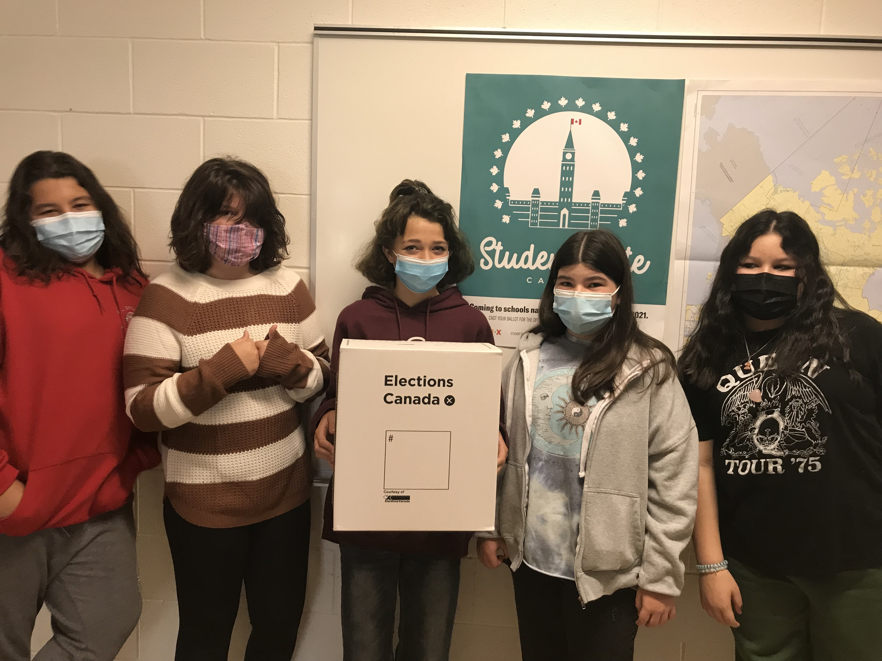
Student Leaders Jacob, Shayna, Elexis, Abigail and Serenity

SUCCESSFUL NEWSLETTER DELIVERY BALLOT
Sign below to indicate that your son/daughter has delivered to you this month’s newsletter. Have your child return this ballot to the ballot box located at the school office by Friday, September 24th. At the end of the month, a draw will be made for a gift certificate from all the ballots that are returned.
____________________________________________________________________________________________________________
Parent Signture Class Student name

